Predicting Compressive Strength of concrete

## 1. INTRODUCTION

#### 1.1. Overview

Concrete is a complex composite material. Compressive strength or compression strength is the capacity of a material or structure to withstand loads tending to reduce size, as opposed to tensile strength, which withstands loads tending to elongate.

The predictability of concrete strength is extremely low. Therefore, it is challenging to create a model with the dependent variables of the concrete. One of the biggest challenge is to consider too many independent variables precisely and get a relation between them.

In this project, we are considering 8 independent variables for predicting the concrete strength. This is dataset can be trained and tested using Multivariant Linear Regression Model which comes under Supervised Machine Learning. We are building and evaluating multiple Machine Learning Models, and finding the lowest RMSE to understand which model has higher accuracy.

#### 1.2. Purpose

To predict the concrete strength of using the composition of its mixture and age of the concrete. Concrete has been widely used in recent years because its production compliments environmental conservation. It is a standard industrial practice that the concrete is classified based on grades. This grade is nothing but the Compressive Strength of the concrete cube or cylinder. Cube or Cylinder samples are usually tested under a compression testing machine to obtain the strength of concrete. The test requisites differ country to country based on the design code.

The prediction of the strength of concrete using nondestructive techniques is of great interest to engineers worldwide. This is mainly because. It saves a lot of money by determining the concrete strength without destruction of any real sample.

## 2. LITERATURE SURVEY

#### 2.1. Existing Problem

Concrete's composition is getting complex day by day. It is mainly because engineers are trying to replace of existing composition with more durable and less expensive one to increase the strength and reduce the overall cost of production. Now, this increases the difficulty in predicting the strength as the number of nonlinear independent variables keeps on increasing day by day. In earlier days, the concrete strength is measure through other traditional methods like using drill holes, weight spring, or using sensors. But that requires a significant destruction of test sample and there by increasing the cost. And the accuracy was also hardly 70%.

#### 2.2. Proposed Solution

With the use of Machine Learning Model, there will be no limitation of the complexity increasing number of variables. This Model and train and test the given population of concrete and with the best performing machine learning model it can effortlessly predict the strength of the concrete with much higher accuracy than traditional methods.

## 

## 3. THEORITICAL ANALYSIS

#### 3.1 Block diagram

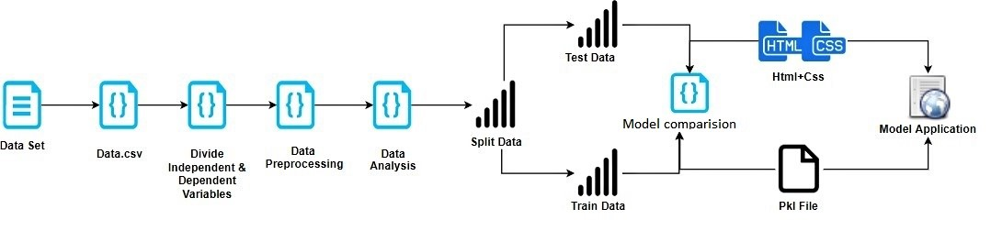

#### 3.2 Hardware / Software designing

* Strategy: matching the problem with the solution.
* Dataset preparation and preprocessing. Data collection. Data visualization. Labeling. Data selection. Data preprocessing. Data transformation.
* Dataset splitting into train data and test data.
* Modeling. Model training. Model evaluation and testing. Improving predictions with ensemble methods.
* Model deployment.

## 4. EXPERIMENTAL INVESTIGATIONS

During our investigation, we got to know all the required parameters to predict the concrete strength and we also analyzed different models and concluded the best model for predicting the output

## 5. FLOWCHART

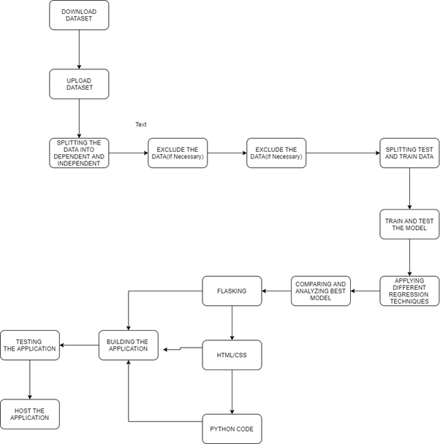

## 6. RESULT

Based on the 8 inputs entered by the user, the model predicts the strength of the concrete prepared and displays the predicted strength

## 7. ADVANTAGES & DISADVANTAGES

#### 7.1. Advantages

* Unlike traditional methods there is no wastage of test samples.
* Higher accuracy can reduces errors in wrong grading of concretes.
* Reduce the cost of finding out strength of concrete.
* Engineers might also be able to play around with the composition and mixture quantity and understand the desired outcome of the concrete strength.
* Easy user interface with straight forward prediction.

#### 7.2. Disa***dvantages***

* The model is limited to predict the concrete strength for only those concretes which have exactly 8 compositions in their mixture.
* The construction mixtures of the concrete needs to be accurately found out before any prediction of concrete strength.

## 8. APPLICATIONS

It can be used to predict the strength of concrete that is made using several parameters

## 9. CONCLUSION

Since any builder working on the concrete strength do not want to waste any of the physical resources for testing purpose ..our application helps in predicting the Strength of the concrete based on the past data

## 

## 10. FUTURE SCOPE

With this model now engineers would be able to determine the self life of the concrete i.e. when will the concrete strength will be below average as per the age of the concrete. Based on this many would be able to advise when a construction with that particular grade of concrete should be renovated.

## 11. BIBILOGRAPHY APPENDIX

**Model Building**

* [Dataset](https://github.com/SmartPracticeschool/llSPS-INT-1336-Predicting-compressive-strength-of-concrete/blob/master/Concrete_Data.csv)
* [Notebook](https://github.com/SmartPracticeschool/llSPS-INT-1336-Predicting-compressive-strength-of-concrete/blob/master/Model.ipynb)

**Application Building**

* HTML 5 and CSS 3 files
* Flask
* Joblib